API resources
Cheat sheet
Below is a cheat sheet I've create for RESTful API calls. You can also download this resource here.
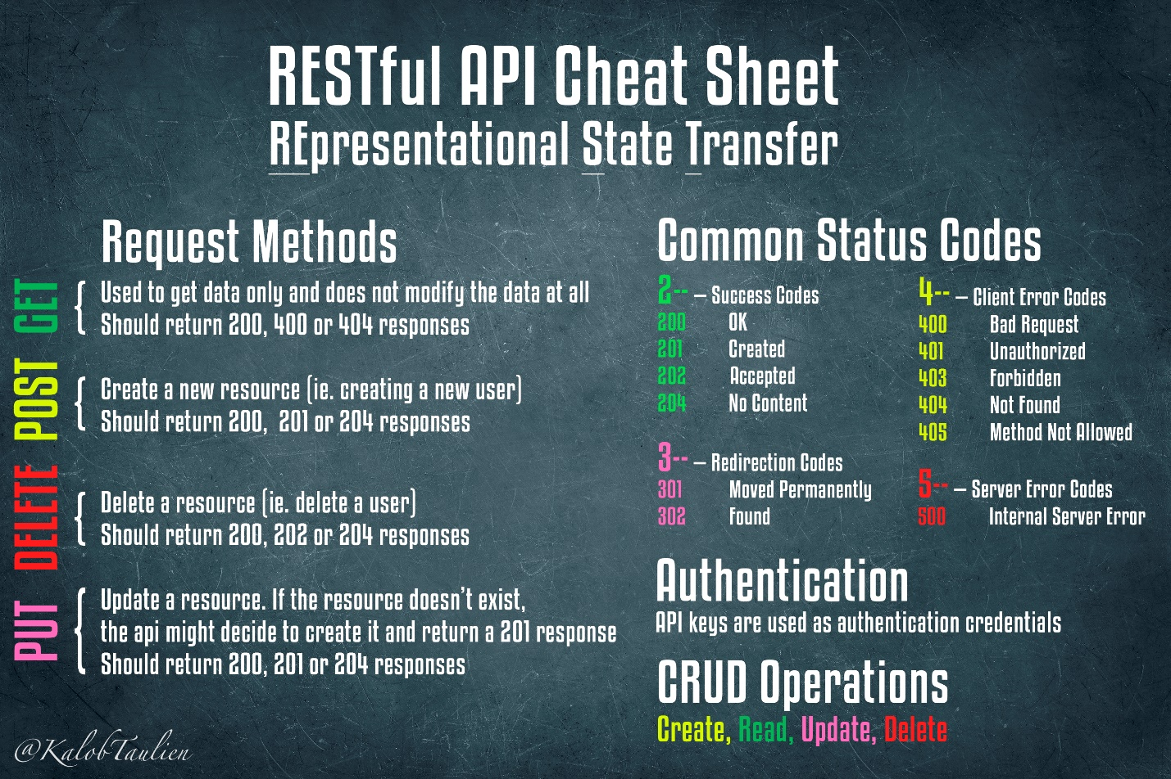
You can also explore this on a really cool webpage I like to visit often: https://devhints.io/rest-api

